Individual or Group letterhead
Date
Memo to: (1) Senator (2) Assemblymember
Email Address:
From: Your name or your group’s name
Subject: Adjust 6th cycle RHNA to reflect DOF’s flat population growth projections through 2060

The CA Dept of Finance (DOF) issued revised population projections showing the population will remain flat through 2060. The findings were published by the Bay Area News Group on July 26, 2023.

The Department of Finance Demographic Research Unit’s previous forecast in July 2021 was based on unrealistic migration assumptions. DOF corrected the numbers and the difference between the two forecasts is dramatic as shown below, based on research by Gaetan Lion.

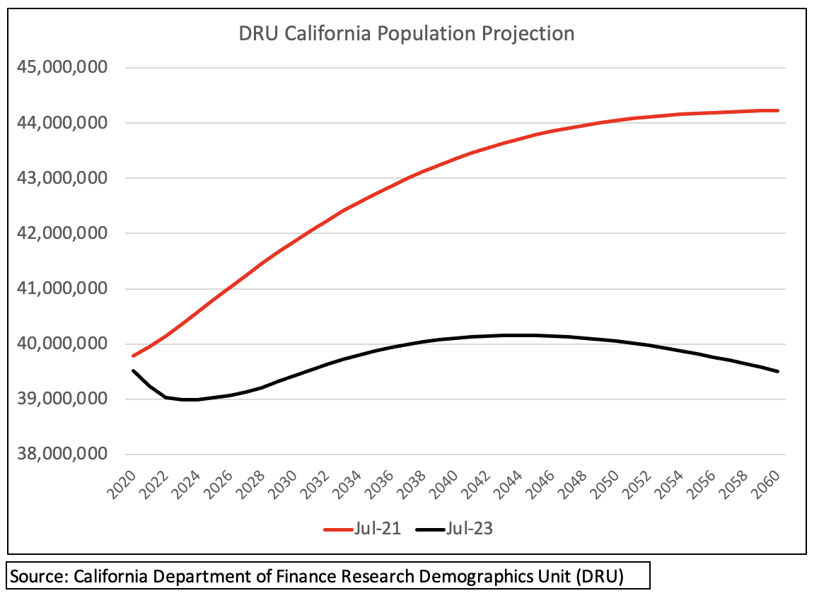

The DOF population numbers impact the RHNA numbers. For the current cycle, RHNA numbers are multiples higher than for the previous cycle. HCD—like the DOF—should adjust the RHNA numbers to reflect California’s slowing growth rate that is expected to remain flat until 2060.

As my legislative representative, I urge you to forward this email to HCD Director Gustavo Velasquez (Gustavo.Velasquez@hcd.ca.gov) and Megan Kirkeby, HCD Deputy Director, Housing Policy Development (Megan.Kirkeby@hcd.ca.gov).

Recommend that HCD retro-actively adjust 6th cycle RHNA numbers to align with the latest data on slowing population growth. Without action to adjust the inflated RHNA numbers, HCD erodes public confidence.

Accurate population projections will generate RHNA numbers that benefit the greatest number of constituents, protect the environment, and bolster sound land use planning and housing policy. Thank you for supporting constituents’ interests.

Best regards,

Name
City, Zip
Cc: info@catalystsca.org

