Catalysts Call
July 31, 2023

Take Action: Make the DOF revised population projections count with HCD.

Goal: In the next week, deliver 900 messages to CA legislators asking them to contact HCD to urge HCD to adjust the 6th cycle RHNA numbers to reflect the new DOF populations forecasts and get housing policy back to track.

Strategy to reach this goal: 25 people on the 7/31 Catalysts Call can generate 900 messages:
50 contacts 25 people email to your senator (25) and your assemblymember (25) with the message: Adjust RHNA to reflect DOF population projections! See sample email below.
500 contacts Email 10 colleagues and ask them to follow your example (25x10x2)
5,000 contacts Email your Neighborhood or Homeowner Association, w/average email list of 200 names (25x200)
6,000 Total number who get information about the DOF update and Catalysts’ request
900 messages Estimated # of messages delivered to HCD Director and the Deputy Director of Housing Policy if 15% take action.

DIRECTIONS

- Use the Catalysts letter/email below to make two copies of your own with your individual or group name on the letterhead.
- Identify your senator and assemblymember and find their email. If you don’t have their email, use this link to get their names. Poke around to find their email or directions to submit your letter through the legislator’s website.
- Tailor one letter for your Senator and another for your Assemblymember. Please include the cc to Catalysts so we can track the impact of this campaign.
- Write a short note to 10 colleagues and your neighborhood or homeowner association and invite them to follow your example and take action.

This is another way we take back local control to govern our communities for constituents’ benefit.

Individual or Group letterhead
Date
Memo to: (1) Senator (2) Assemblymember
Email Address:
From: Your name or your group’s name
Subject: Adjust 6th cycle RHNA to reflect DOF’s flat population growth projections through 2060

The CA Dept of Finance (DOF) issued revised population projections showing the population will remain flat through 2060. The findings were published by the Bay Area News Group on July 26, 2023.

The Department of Finance Demographic Research Unit’s previous forecast in July 2021 was based on unrealistic migration assumptions. DOF corrected the numbers and the difference between the two forecasts is dramatic as shown below, based on research by Gaetan Lion.

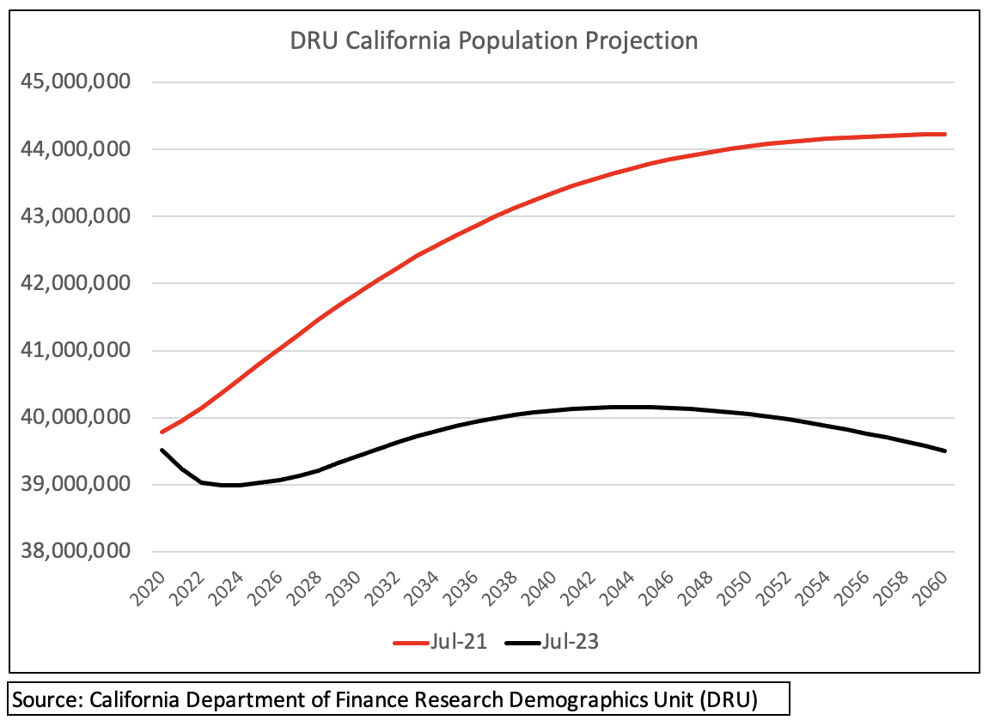

The DOF population numbers impact the RHNA numbers. For the current cycle, RHNA numbers are multiples higher than for the previous cycle. HCD—like the DOF—should adjust the RHNA numbers to reflect California’s slowing growth rate that is expected to remain flat until 2060.

As my legislative representative, I urge you to forward this email to HCD Director Gustavo Velasquez (Gustavo.Velasquez@hcd.ca.gov) and Megan Kirkeby, HCD Deputy Director, Housing Policy Development (Megan.Kirkeby@hcd.ca.gov).

Recommend that HCD retro-actively adjust 6th cycle RHNA numbers to align with the latest data on slowing population growth. Without action to adjust the inflated RHNA numbers, HCD erodes public confidence.

Accurate population projections will generate RHNA numbers that benefit the greatest number of constituents, protect the environment, and bolster sound land use planning and housing policy. Thank you for supporting constituents’ interests.

Best regards,

Name
City, Zip
Cc: info@catalystsca.org

