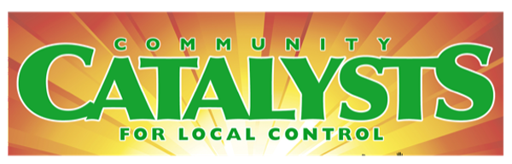
PO Box 1703, Mill Valley, CA 94942
CatalystsCA.org 416-686-4375

In District Lobby Day Campaign
(Oct 16-20, 2023)

Meeting Schedule: Team Leaders and Constituent Participants
Meetings are on Zoom. Use the Catalysts Call link.

Th Sept 28, 5:00-6:30 pm - Team Leader and Participant Orientation
Th Oct 5, 5:00-6:30 pm - Orientation for newcomers and more Q&A
WEEK OF OCTOBER 16-20 - Local meetings as arranged by Team Leaders
Th Oct 26, 5:00-6:30 pm – Team Leader and Participant Debrief, Insights, Action

