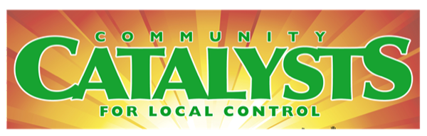
PO Box 1703, Mill Valley, CA 94942
CatalystsCA.org 416-686-4375

In-District Lobby Day Campaign (October 16-20th)
30-minute MEETING REQUEST
Date: ______
To: (scheduler)_________________
RE: Appointment Request: 30-minute in-person meeting for the week of Oct 16-20
My name is _________________. I’m a Team Leader for Catalysts for Local Control’s In-District Lobby Day. I’m a constituent of Sen/Asm __________and have been a resident of ______________ for _____ years.
Along with other leaders in this district, 5-10 other constituents and I want to visit you in your district office (if there’s more than one office, specify which one) for a 30-minute meeting. The purpose of the meeting is to discuss state and local housing policy and the need for reliable numbers to calculate housing needs and restore trust.
I look forward to hearing from you. I will call you to follow up.
Thank you,
Your name,
Team Leader, Catalysts for Local Control
Your email
Your phone

